# EXNO:1 USER INTERFACE DESIGN 230701244

# CREATION OF GOOD UI FROM AN BAD UI

BAD UI:

1. **The buttons look different from each other.**

2. **The items are not spaced evenly.**

3. **It's hard to tell what's most important.**

4. **The colors are boring.**

5. **It's not clear what you should do.**

UPDRADE OF THE UI :

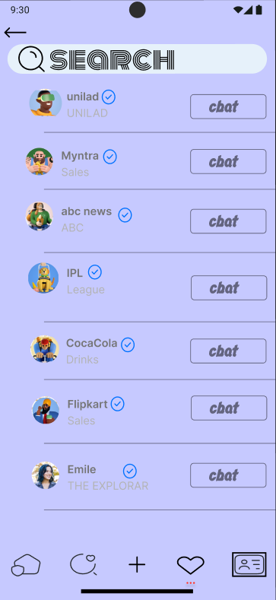

POINTS:

1. **The buttons look the same.**

2. **It's easy to see what's important.**

3. **There's a lot of empty space, which makes it look nice.**

4. **It's simple and easy to understand.**

5. **The colors are used well.**

6. **The buttons are easy to press.**

**LINK :** **https://www.figma.com/design/2bI7mrYHuusAVCawT65DOy/Sharegram-2.0?m=auto&t=SoG1sxF9aUgsBJGV-6**